**FET3399-C System on Module (SoM) with Rockchip RK3399**

1. **Rockchip RK3399 Android Main Development Board with Dual Band Wi-Fi USB3.0**

**Product Description**

OK3399-C is a development board designed based on RK3399 processor which consists of two Cotex-A72 featuring cores with frequency up to 1.8GHz and four Cortex-A53 featuring cores with frequency up to 1.4GHz. It's integrated with GPU Mali-T864, can support OpenGL ES1.1/ 2.0/ 3.0/ 3.1, OpenVG1.1, OpenCL and DX11. It has on-board 2GB LPDDR3 RAM and 16GB eMMC. A variety of display interfaces such as HDMI2.0, MIPI-DSI, eDP1.3 and DP1.2 are all available and resolution up to 4K. Dual-screen both synchronous and asynchronous playing are well supported. Besides, it carries PCIe, USB3.0 Host, Type-C, MIPI-CSI, SPDIF, IIC, SPI, UART, ADC, PWM, GPIO, IIS (8 digital microphone array input) and Ethernet on board.

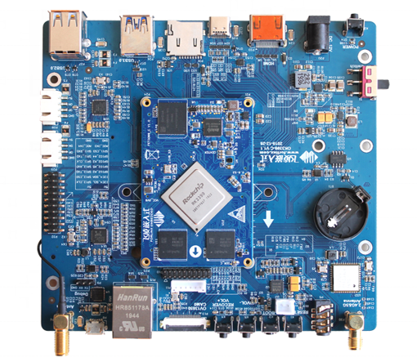

* **Model Number:** OK3399-c
* **Type:** Development Board
* 4K output, hexa-core advanced performance and multiple AI frameworks
* FET3399-C SoM is based on Rockchip RK3399 SoC.
* **CPU:** 2*Cortex-A72@ 1.8GHz & 4*Cortex-A53@ 1.4GHz, 64-bit ARMv8
* **GPU:** Quad Core GPU Mali-T860MP4
* **VPU:** H.265/HEV/VP9/H.264
* **RAM:** **2GB (4GB optional) LPDDR3**
* **Flash:** 16GB (32GB optional), eMMC5.1, HS400
* **Display:** HDMI 2.0, MIPI-DSI, eDP 1.3, DP 1.2
* **Interface:** PCIe2.0 (SSD optional), Type-C & USB 3.0, MIPI-CSI, SPDIF, IIC, SPI, UART, ADC, PWM, GPIO, IIS (8 digital micphone array input) and Ethernet on board.
* **Output:** 4K high resolution output
* Support hardware codec
* AI computing
* Optimized target detection deep learning solution
* Use OpenCL RGA accelerating modules to detect target object
* **Operating System:** Android 7.1, Linux 4.4.189
* **Camera:** can support one 13.0MP camera or two 8.0MP cameras, 2 built-in ISP, one ISP up to 14.0MP. **USB UVC:** can support USB UVC camera input
* **Voltage input:** 12V
* **Working temp:** 0℃~80℃
* Price: **$150.00 - $200.00**

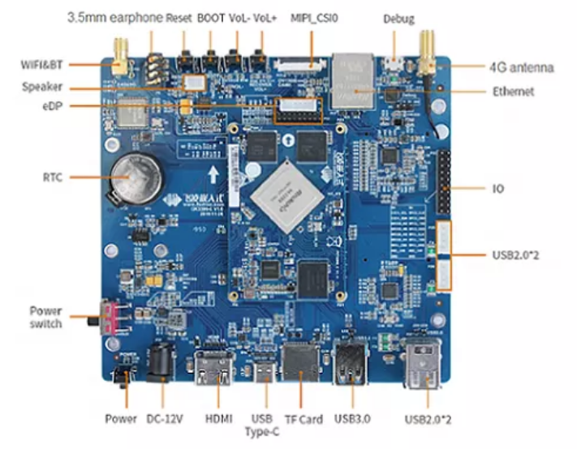**Pin Diagram:**

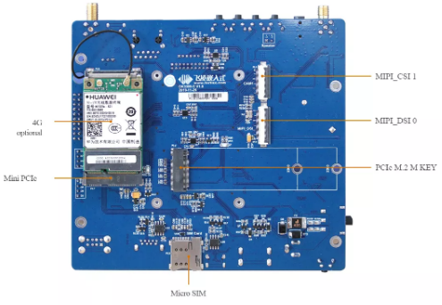

**Other Development Boards of FET3399-C:**

1. **RK3399 Development Board with 4GB RAM 32GB eMMC MIPI DSI CSI**

**Price:** **$185.00 - $215.00**

1. **Rockchip Rk3399 Android Development Board Evaluation Board**

**Price: $180.00 - $230.00**

1. **RK3399 Development Board Android Linux Single Board Computer**

**Price: $150.00 - $200.00**

1. **Android 7.1 RK3399 TV Box Motherboard Development Kit**

**Price: $180.00 - $250.00**